Web Mining Lab Assignment 4

Name: Om Ashish Mishra

Registration Number: 16BCE0789

Slot: F2

# The Question:

Write a python program to perform the following encoding for the ODD numbers between 1 – 30 i) Elias Gamma ii) Elias Delta iii) Golomb (b = 10)

# The Answer:

1. Urany Encoding:

**The Code:**

for i in range(1,30,2):

print("1"*i+"0")

**The Output:**

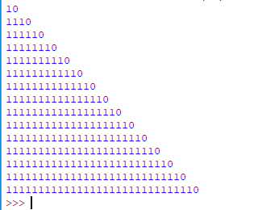

2. Elias Gamma Encoding:

**The Code:**

c=0

s=""

for i in range(1,30,2):

c=0

s=format(i,"b")

for j in range(len(s)):

c=c+1

s1 = "0"*(c-1)+s

print(s1)

s1=0

**The Output:**

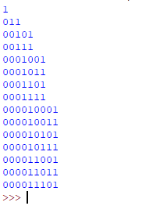

3. Elias Delta Encoding:

**The Code:**

import math

count=0

k1=0;

s2=""

s1=""

s=""

c=0

for i in range(1,30,2):

a = math.log2(i)

b = math.floor(a)

c = b+1

d = format(c,"b")

count=0

for j in range(len(d)):

count=count+1

s1 = "0"*(count-1)+d

f = format(i,"b")

g = f[1:]

s3 = s1+g

print(s3+"\n")

**The Output:**

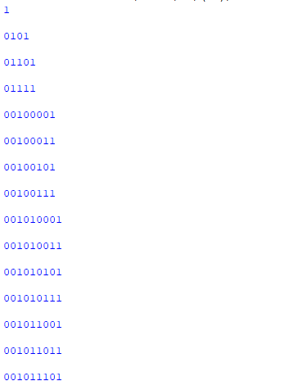

4. Golumb Encoding:

**The Code:**

from math import *

n=[i for i in range(1,31,2)]

def unary(n):

if n==0:

return '0'

return ('0'*n + '1')

def golumb(n,b):

q= n//b

r = n-q*b

x1 = unary(q)

ubits = ceil(log(b,2))

bitlength= 2**ubits - b

if(r>=bitlength):

return x1+bin(r + bitlength)[2:].zfill(ubits)

else:

return x1+bin(r )[2:].zfill(ubits-1)

for i in n:

print(golumb(i,10))

**The Output:**

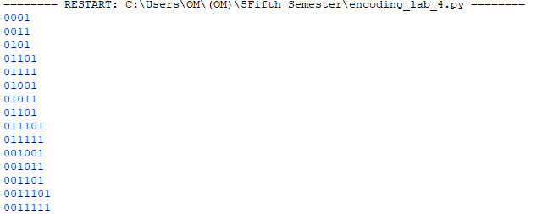

5. Variable Byte Coding:

**The Code:**

for i in range(1,30,2):

a = format(i,"b")

c = len(a)

if c < 7:

c = "0"*(7-c)+a

print(c+"0"+"\n")

else:

b = c[:-7]

print(b+"0"+"\n")

e = c[0:8]

print(e+"1\n")

**The Output:**

